Types of Diction

🔸 1. Word Choice (Style)
# Source: Chatgpt (GPT-4-turbo) at [7/30/2025]
Refers to how formal, informal, poetic, technical, or emotionally charged the language is.
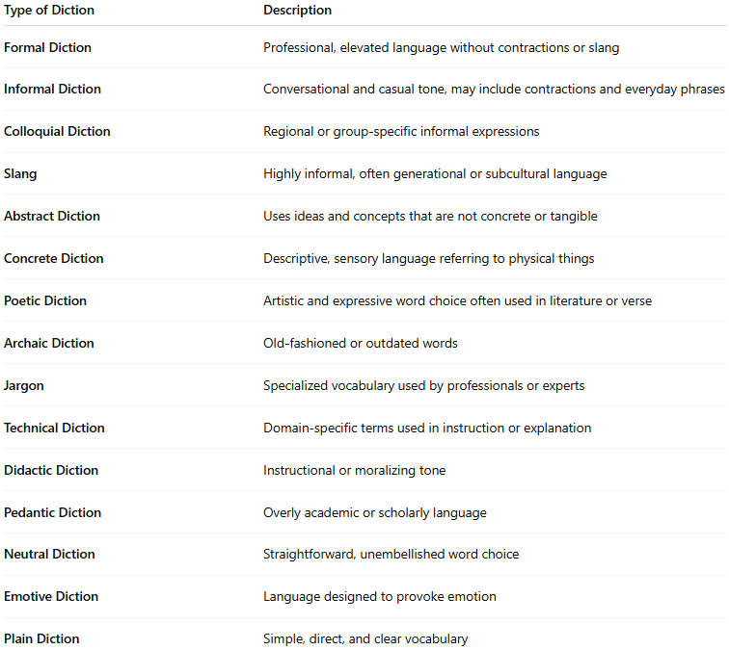
Type of Diction | Description
Formal Diction | Professional, elevated language without contractions or slang
Informal Diction | Conversational and casual tone, may include contractions and everyday phrases
Colloquial Diction | Regional or group-specific informal expressions
Slang | Highly informal, often generational or subcultural language
Abstract Diction | Uses ideas and concepts that are not concrete or tangible
Concrete Diction | Descriptive, sensory language referring to physical things
Poetic Diction | Artistic and expressive word choice often used in literature or verse
Archaic Diction | Old-fashioned or outdated words
Jargon | Specialized vocabulary used by professionals or experts
Technical Diction | Domain-specific terms used in instruction or explanation
Didactic Diction | Instructional or moralizing tone
Pedantic Diction | Overly academic or scholarly language
Neutral Diction | Straightforward, unembellished word choice
Emotive Diction | Language designed to provoke emotion
Plain Diction | Simple, direct, and clear vocabulary

🔸 2. Pronunciation (Speech Clarity)
# Source: Chatgpt (GPT-4-turbo) at [7/30/2025]
Refers to how clearly and correctly words are spoken, often relevant in spoken language, not written.
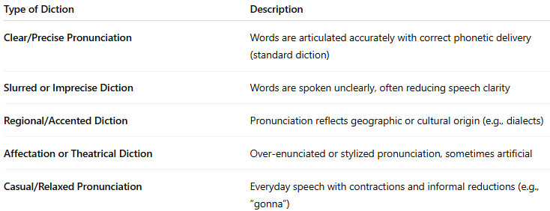
Type of Diction | Description
Clear/Precise Pronunciation | Words are articulated accurately with correct phonetic delivery (standard diction)
Slurred or Imprecise Diction | Words are spoken unclearly, often reducing speech clarity
Regional/Accented Diction | Pronunciation reflects geographic or cultural origin (e.g., dialects)
Affectation or Theatrical Diction | Over-enunciated or stylized pronunciation, sometimes artificial
Casual/Relaxed Pronunciation | Everyday speech with contractions and informal reductions (e.g., “gonna”)
🗣️ These aspects of pronunciation often affect how formal, credible, or approachable a speaker sounds.

